School of Computing and Information Technology

Engineering Exploration

**Activity Report-1**

Submitted by:

|  |  |  |
| --- | --- | --- |
| Name of the student | : | BHUVAN BHAT |
| Name of the Program | : | AIML/CSIT/CSSE/ISE |
| Name of the Activity | : | Tyre Literacy:  Unlocking the Secrets of Tyre Labels |
| Section | : | A SECTION (AIML) |
| Number of team members | : | 2 (TWO) |
| Name of the team member(s) | : | PREETAM A.K. |
| Date of Activity | : | 30TH OCTOBER (WEDNESDAY) |
| Date of report submission | : | 8TH NOVEMBER (FRIDAY) |
| Title of the course | : | Engineering Exploration |
| Course code | : | B24CSET01 |
| Name of the faculty | : | Dr. Harsha B K |

# INTRODUCTION

In modern automotive design, tyres are a critical component influencing vehicle performance, safety, and efficiency. Tyre markings, often an overlooked detail, provide essential information that helps drivers and manufacturers ensure compatibility, reliability, and safety on the road. These alphanumeric codes on the tyre wall indicate various specifications, including tyre size, load capacity, speed rating, and manufacturing details, each playing a vital role in the tyre’s functionality and performance.

## Objectives

The objectives of this activity is to provide students with practical, hands-on experience in identifying, interpreting, and analyzing tyre markings found on different vehicle types. Through this activity, students will:

1. **Recognize and identify key tyre specifications** – Develop familiarity with the common markings on a tyre, including tyre size, load index, speed rating, Department of Transportation (DOT) code, and other essential symbols.
2. **Understand the significance of tyre markings** – Gain insights into how each marking impacts tyre performance, durability, and safety, and understand why these specifications are crucial for different vehicle applications.
3. **Develop observational and data collection skills** – Learn how to systematically gather and document information from physical objects (in this case, tyres), ensuring accuracy and adherence to ethical guidelines, such as protecting vehicle owner privacy.
4. **Apply theoretical knowledge in a real-world context** – Connect the theoretical aspects of vehicle dynamics and safety with practical examples by decoding real tyres, promoting a deeper comprehension of engineering principles.
5. **Enhance teamwork and communication** – Work collaboratively with a partner to complete the task, effectively communicating findings and analyzing data to draw meaningful conclusions.

By the end of this activity, students will have a well-rounded understanding of tyre specifications and be able to interpret tyre markings confidently, enabling them to make informed decisions regarding tyre compatibility, maintenance, and safety in their future automotive and engineering endeavours.

This activity will give students hands-on experience with decoding tyre markings by observing real vehicles within the REVA University parking lot. Working in teams of two, students will photograph the tyres of a two-wheeler, a car, and a bus, carefully record the markings, and decode their meaning. Through this process, students will gain insights into how tyre markings inform critical choices in vehicle maintenance, performance, and safety standards.

## Theory (Indian Standards)

Tyre markings are critical for understanding a tyre’s specifications and suitability for Indian roads. These markings, regulated by the Bureau of Indian Standards (BIS), provide details about tyre size, load capacity, speed rating, manufacturing origin, and purpose, each affecting the safety, performance, and compatibility of the tyre. Let’s explore each of these markings in detail.

### Tyre Size

In India, tyre sizes follow the metric standard and typically look like **205/55R16**. This marking sequence indicates the tyre’s width, aspect ratio, construction type, and wheel diameter.

* **Width (205)**: The tyre’s width in millimeters, measured from sidewall to sidewall. Wider tyres offer more grip on Indian roads but can slightly reduce fuel efficiency.
* **Aspect Ratio (55)**: This number is the sidewall height as a percentage of the tyre's width. Lower aspect ratios are common in performance tyres, whereas higher ratios are typical for off-road and heavy-load vehicles.
* **Construction Type (R)**: The letter "R" stands for radial construction, the most common type in India. Radial tyres have steel belts running at 90 degrees to the tread line, offering durability and better handling.
* **Wheel Diameter (16)**: Measured in inches, this number refers to the diameter of the wheel on which the tyre fits.

*Illustration Suggestion:* A labelled diagram of a tyre marking like **205/55R16**, with arrows pointing to **205**, **55**, **R**, and **16** for each specification, annotated in millimetres and inches as needed.

### Load Index and Speed Rating

The load index and speed rating indicate the tyre’s load-bearing capacity and maximum safe speed.

* **Load Index (91)**: This numerical value shows the maximum load the tyre can support in kilograms. A load index of 91 indicates a load capacity of 615 kg. Refer to a standard load index chart for more values.
* **Speed Rating (V)**: The speed rating is marked by a letter, corresponding to the maximum speed in kilometres per hour (km/h). Common ratings in India include:
  + **S**: Up to 180 km/h
  + **T**: Up to 190 km/h
  + **H**: Up to 210 km/h
  + **V**: Up to 240 km/h

*Illustration Suggestion:* An image showing a **91V** marking, with annotations explaining the load in kilograms and the speed in kilometres per hour, adjusted to Indian road limits.

### DOT Code and BIS Marking

The DOT code (Department of Transportation) provides details on tyre manufacturing, helping track manufacturing origins and ensuring compliance with safety regulations. In India, the Bureau of Indian Standards (BIS) marking is also essential.

* **DOT Code**: This code includes a series of letters and numbers. For example, **DOT X9 RV T5M 2519**:
  + **Plant Code (X9)**: Identifies the manufacturing location.
  + **Size Code (RV)**: Specifies the tyre size.
  + **Brand Characteristics (T5M)**: Manufacturer-specific code.
  + **Date Code (2519)**: Indicates the week and year of manufacture (25th week of 2019).
* **BIS Mark**: A symbol representing certification by the Bureau of Indian Standards, signifying compliance with Indian safety and quality regulations.

*Illustration Suggestion:* A close-up of a DOT and BIS marking with the various sections color-coded or labelled to highlight plant, size, brand, and date codes, along with the BIS symbol.

### Tyre Type Symbols

Tyre symbols in India indicate the tyre’s suitability for different conditions, including seasonal and off-road capabilities.

* **M+S (Mud and Snow)**: This symbol, common on all-season tyres, indicates suitability for moderate off-road conditions and better grip on wet or muddy surfaces.
* **All-Season**: Generally marked by "A/S," this symbol shows that the tyre is designed for year-round use in India’s varying weather conditions.
* **Snowflake (Severe Snow Conditions)**: While not very common in India, some tyres may display a snowflake symbol, indicating adherence to severe snow performance standards. This is useful for colder regions of India like the Himalayas.

*Illustration Suggestion:* Images of each symbol (M+S, All-Season, Snowflake) with captions explaining how they apply to Indian driving conditions.

## Practical Significance of Tyre Markings

Each marking provides vital details influencing tyre performance and safety:

* **Tyre Size**: Ensures compatibility with the vehicle, affecting handling and efficiency, crucial for Indian roads with diverse terrains.
* **Load Index and Speed Rating**: Important for selecting tyres that match the vehicle’s specifications and road conditions, optimizing load capacity and stability.
* **DOT and BIS Codes**: Assist in identifying the tyre’s manufacturing origin and quality compliance with Indian standards, ensuring a safe and reliable choice.
* **Tyre Type Symbols**: Help users choose tyres suitable for specific weather and road conditions, enhancing traction and safety on Indian roads.

By decoding and understanding these markings, students will gain essential knowledge that will allow them to make informed decisions about tyre selection and maintenance for Indian driving conditions.

# PROCEDURE

This section provides step-by-step instructions for conducting the tyre markings activity. Follow each step carefully to ensure accurate data collection, maintain decorum, and respect privacy and property.

Step 1: Preparation

1. **Form Teams**: Partner up with one other student as each team will consist of two members.
2. **Gather Materials**: Each team should carry:
   * A notebook and pen (for noting observations).
   * Two mobile phones with cameras (for capturing images).
   * A water bottle.
3. **Wear ID Cards**: ID cards should be visible at all times for identification.
4. Review Safety and Privacy Guidelines:
   * Do not touch or lean on any vehicle.
   * Ensure vehicle registration numbers are not visible in your photos.
   * Handle all vehicles with care and respect, ensuring no disturbance to others’ property.

Step 2: Selecting Tyres for Data Collection

1. **Choose Vehicles**: Identify one two-wheeler, one car, and one bus in the parking lot.
2. Plan Photo Angles:
   * Ensure the tyre markings on each vehicle are clearly visible in your photo.
   * If necessary, crouch or adjust your angle to capture all essential markings.

Step 3: Capturing Photos of Tyres

1. **Position Camera**: Hold the camera steady, focusing on the tyre sidewall with markings visible.
2. Frame the Markings:
   * Capture the tyre’s full markings, including size, load index, speed rating, DOT code, and any additional symbols.
   * Make sure the markings are readable in the photo.
3. Check for Privacy Compliance:
   * Double-check that no vehicle registration numbers are visible.
   * Confirm that only the tyre (and no other identifying features) is in the frame.
4. **Take a Selfie**: Take a selfie with one of the tyres to show your participation, ensuring it does not include any identifying features of the vehicle except the tyre.

# DECODING THE TYRE

In this section we learn to read a tyre size and its maximum load and speed and find out how the brand, range and tyre type, are shown on your tyre. We will also learn about other tyre markings such as the snowy mountain symbol, M+S letters and the significance of the OE marking.

## What do the numbers on tyres mean?

If you look at the sidewall of your tyre, you will notice numerous alphanumeric codes and symbols. These tyre markings give you important information about tyre usage or replacement.

## How to read a tyre size?

The dimension of the tyre is defined by numbers and a letter, as shown in Figure 1 in yellow. Note that these characters are sometimes accompanied by additional letters that indicate the recommended use of the tyre.

Such letters could be:

* **P**: Passenger Car
* **LT**: Light Truck
* **C:**Van commercial tyre
* **XL, HL or Reinforced:** Tyres with a higher load capacity than normal for their dimension. Such tyres need to be replaced by the equivalent (example : an HL tyre by another HL tyre)
* **T**: Temporary (spare wheels)

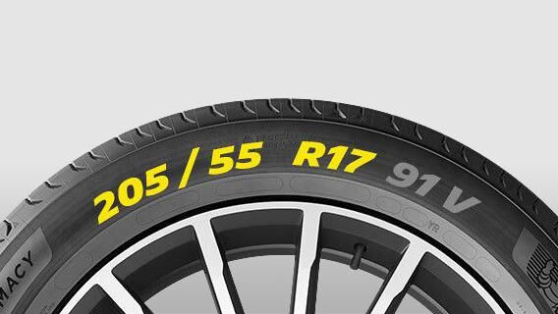

Figure 1: Sidewall of a wheel

## How to read a tyre width and the aspect ratio?

Example: 205 / 55

These are important tyre markings that will help you find the right tyre when you need to change it.

The first of the two numbers is the nominal section width of the tyre. It is given in millimetres and defines the distance between the inner and outer sidewall of the tyre. For example, 205 means that your tyre is nominally 205 mm wide.

The second number is the relationship between a tyre’s sidewall height and the tyre's width. It is expressed as a percentage. For example, 55 indicates that the sidewall height, between the top of the tread and the rim, is 55% of the tyre width.

## How to read a tyre construction type and the wheel diameter?

Example: R 17

These tyre markings are usually composed of a letter and a number. The letter, R, indicates that the tyre’s internal construction is Radial. Radial technology, uses combinations of rubbers and metal and textile reinforcing materials to form very robust structures in the tread area but flexible sidewalls. It allows a longer tread life and reduces fuel consumption thanks to the reduction of the rolling resistance.

After the letter you will find a number. In our example: 17. This number is expressed in inches and indicates the diameter of the wheel on which the tyre is designed to fit.

## How to identify the brand name and range of the tyre?

As shown in figure 2, this is quite easy. The manufacturer's brand name is always showing on the sidewall, as is the range of the tyre. In this picture, MICHELIN and our Michelin Man are clearly visible and the name "[Pilot Sport ⁴ ˢ](https://www.michelin.in/auto/tyres/michelin-pilot-sport-4-s)" refers to the range of the tyre.

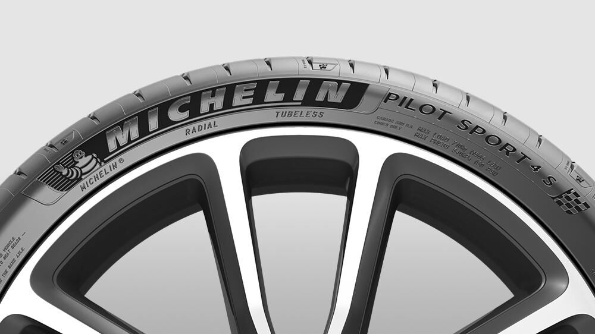

Figure 2: Sample brand name and range

## How to identify the type of tyre?

The word "Tubeless" on the sidewall of tyre as shown in figure 3, indicates that the tyre does not require an inner tube. Note that a tube is sometimes necessary for certain wheels, but in such cases, it is important to assess if the tube and tyre are compatible.  
Conversely, the word "Tube type" indicates that the tyre requires to be fitted with a tube.  
What is the benefit? A tubeless assembly is lighter, more fuel efficient and often more reliable owing to damage that can occur to the tube in service.

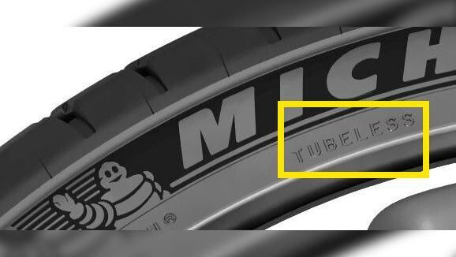

Figure 3: Tyre type

## Tyre markings

**Snowy mountain** A logo consisting of a mountain of 3 peaks as shown in figure 4 with a snowflake may be present on your tyre. This is the three peak mountain snowflake or 3PMSF label: the most recent standard for winter or snow tyres. It guarantees a minimum level of winter performance because there is an objective test for tyres marked in this way. This logo on your tyre ensures that it is considered as recommended equipment to access areas under regulation.

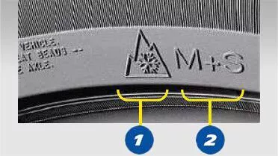

Figure 4: Snowy mountain

**M+S mention** Some tyres are marked with M+S on the sidewall as shown in figure 4, including all-season and winter tyres. These letters simply stand for the words "Mud" and "Snow" and indicate that the tyre is, according to the manufacturer, a “snow” tyre.  However, for tyres with only M+S markings performance under winter conditions is not subject to regulatory testing. Only tyres marked “3PMSF” guarantee real winter performance by being specifically designed for snow use and having fulfilled all of the requirements through objective testing.

## Miscellaneous Markings

Apart from these, as mentioned earlier, you can find other information as shown in figure 5.

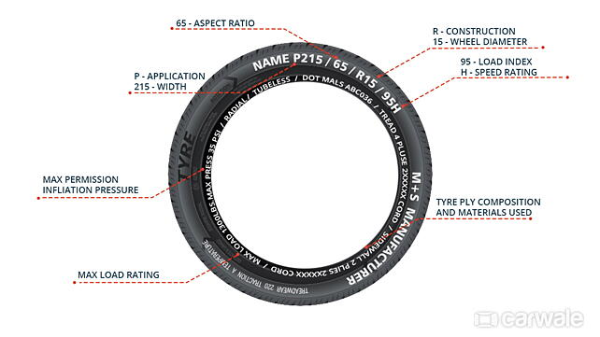

Figure 5: Miscellaneous markings

**P – Application:** The first alphabet, in this case, is P which indicates the application of tyre. P stands for the passenger in this case. An ‘LT’ indicates the tyre would be for a light truck with a heavier load rating and so on.

**95 – Load Index:** The load index relates to the maximum load-carrying capacity of the tyre. The lower profile tyres tend to have lower load ratings compared to higher-profile ones. Fitting an incorrect load rating will seriously compromise safety and can result in a serious accident. This number is just an index and needs to be checked with the corresponding weight (in kgs) in the manufacturer’s tabloids. For instance, a load index of 95 here corresponds to the 690kg as shown in table 1, of load-carrying capacity of the tyres.

Table 1: Load Index

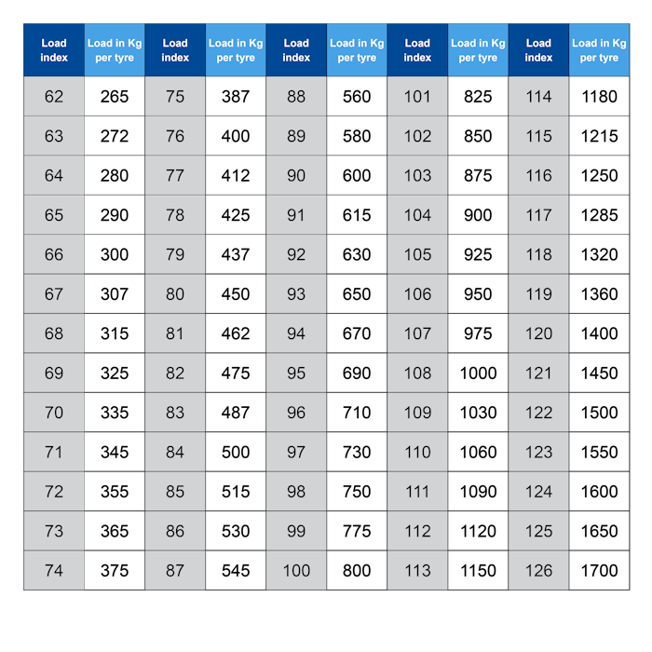

**H – Speed Rating:** Similar to the load index, the speed rating is the maximum service speed your tyre is capable of maintaining. The speed rating will give you the speed your tyre can endure without failure. Speed ratings are specific for passenger car tyres and not light truck tyres since LT marked tyres are not speed rated. It is essential to keep in mind the corresponding speeds to the speed rating before pushing the vehicle to its limits, to prevent unforeseen failures.

Table 2: Tyre Speed Rating Chart

|  |  |
| --- | --- |
| **Tyre Speed Rating (Letter)** | **Maximum Speed (km/h)** |
| L | 120 |
| M | 130 |
| N | 140 |
| P | 150 |
| Q | 160 |
| R | 170 |
| S | 180 |
| T | 190 |
| U | 200 |
| H | 210 |
| V | 240 |
| W | 270 |
| Y | 300 |
| (Y) | 300+ |

**Directional arrows** – In a unidirectional tyre, it is necessary to fit the tyre in a particular forward direction. Hence the arrow helps to fit the tyre facing the right direction. Asymmetrical tyres have ‘in/out’ mentioned since it needs to be fitted with a bigger tread, half on the outside wall for proper functioning.

**Date of manufacturing** – Some manufacturers provide the month and year the tyre was built. Since it’s made of rubber, deterioration over a certain period of time can lead to reduced quality of the tyre.

**Inflation pressure (in PSI)** – This is the appropriate pressure that the tyre needs to maintain. It has a huge impact on tyre performance and it should be taken care of in order to extract optimum performance, fuel economy, wear and tear and prolong the tyre life.

**Temperature indicator** – The minimum and maximum temperature range the tyre could sustain is indicated so as to not take the tyre beyond its working temperatures.

**Approval signature** – The approved signature for the authority assuring the tyre has passed inspection and is compliant with all the regulations.

# Task-1

Two-wheeler front wheel (Paste the image in the photo image inside the box)

|  |
| --- |
|  |

|  |  |  |
| --- | --- | --- |
| **SL** | **Tyre marking** | **Value** |
| 1 | Tyre width in (mm) | 180 mm |
| 2 | Aspect Ratio (%) | 50% |
| 3 | Diameter (Inches) | 17 INCHES |
| 4 | Brand Name | TVS |
| 5 | Tyre type | TUBELESS |
| 6 | Load Index | 70 |
| 7 | Load-carrying capacity (kgs) | 335 KG |
| 8 | Speed Rating letter | J |
| 9 | Maximum service speed (km/h) | 100KMPH |
| 10 | Vehicle type | BIKE |

# Task-2

Two-wheeler rear wheel (Paste the image in the photo image inside the box)

|  |
| --- |
|  |

|  |  |  |
| --- | --- | --- |
| **SL** | **Tyre marking** | **Value** |
| 1 | Tyre width in (mm) | 160 mm |
| 2 | Aspect Ratio (%) | 50% |
| 3 | Diameter (Inches) | 17 INCHES |
| 4 | Brand Name | CEAT |
| 5 | Tyre type | TUBELESS |
| 6 | Load Index | 70 |
| 7 | Load-carrying capacity (kgs) | 335 KG |
| 8 | Speed Rating letter | F |
| 9 | Maximum service speed (km/h) | 80 |
| 10 | Vehicle type | Scooter/Bike |

# Task-3

Four-wheeler front right wheel (Paste the image in the photo image inside the box)

|  |
| --- |
|  |

|  |  |  |
| --- | --- | --- |
| **SL** | **Tyre marking** | **Value** |
| 1 | Tyre width in (mm) | 245 mm |
| 2 | Aspect Ratio (%) | 50 |
| 3 | Diameter (Inches) | 18 INCHES |
| 4 | Brand Name | YOKOHAMA |
| 5 | Tyre type | TUBELESS |
| 6 | Load Index | 95 |
| 7 | Load-carrying capacity (kgs) | 690 |
| 8 | Speed Rating letter | L |
| 9 | Maximum service speed (km/h) | 120 KMPH |
| 10 | Vehicle type | SUV |

# Task-4

Four-wheeler front left wheel (Paste the image in the photo image inside the box)

|  |
| --- |
|  |

|  |  |  |
| --- | --- | --- |
| **SL** | **Tyre marking** | **Value** |
| 1 | Tyre width in (mm) | 245 mm |
| 2 | Aspect Ratio (%) | 50 |
| 3 | Diameter (Inches) | 18 INCHES |
| 4 | Brand Name | YOKOHAMA |
| 5 | Tyre type | TUBELESS |
| 6 | Load Index | 95 |
| 7 | Load-carrying capacity (kgs) | 690 |
| 8 | Speed Rating letter | L |
| 9 | Maximum service speed (km/h) | 120 KMPH |
| 10 | Vehicle type | SUV |

# Task-5

Four-wheeler rear right wheel (Paste the image in the photo image inside the box)

|  |
| --- |
|  |

|  |  |  |
| --- | --- | --- |
| **SL** | **Tyre marking** | **Value** |
| 1 | Tyre width in (mm) | 245 mm |
| 2 | Aspect Ratio (%) | 50 |
| 3 | Diameter (Inches) | 18 INCHES |
| 4 | Brand Name | YOKOHAMA |
| 5 | Tyre type | TUBELESS |
| 6 | Load Index | 95 |
| 7 | Load-carrying capacity (kgs) | 690 |
| 8 | Speed Rating letter | L |
| 9 | Maximum service speed (km/h) | 120 KMPH |
| 10 | Vehicle type | SUV |

# Task-6

Four-wheeler rear left wheel (Paste the image in the photo image inside the box)

|  |
| --- |
|  |

|  |  |  |
| --- | --- | --- |
| **SL** | **Tyre marking** | **Value** |
| 1 | Tyre width in (mm) | 245 mm |
| 2 | Aspect Ratio (%) | 50 |
| 3 | Diameter (Inches) | 18 INCHES |
| 4 | Brand Name | YOKOHAMA |
| 5 | Tyre type | TUBELESS |
| 6 | Load Index | 95 |
| 7 | Load-carrying capacity (kgs) | 690 |
| 8 | Speed Rating letter | L |
| 9 | Maximum service speed (km/h) | 120 KMPH |
| 10 | Vehicle type | SUV |

# Task-7

Bus front right wheel (Paste the image in the photo image inside the box)

|  |
| --- |
|  |

|  |  |  |
| --- | --- | --- |
| **SL** | **Tyre marking** | **Value** |
| 1 | Tyre width in (mm) | 295 mm |
| 2 | Aspect Ratio (%) | 80% |
| 3 | Diameter (Inches) | 22.5 INCHES |
| 4 | Brand Name | APOLLO |
| 5 | Tyre type | TUBE |
| 6 | Load Index | 126 |
| 7 | Load-carrying capacity (kgs) | 1700 KG |
| 8 | Speed Rating letter | C |
| 9 | Maximum service speed (km/h) | 60 KMPH |

# Task-8

Bus front left wheel (Paste the image in the photo image inside the box)

|  |
| --- |
|  |

|  |  |  |
| --- | --- | --- |
| **SL** | **Tyre marking** | **Value** |
| 1 | Tyre width in (mm) | 295 mm |
| 2 | Aspect Ratio (%) | 80% |
| 3 | Diameter (Inches) | 22.5 INCHES |
| 4 | Brand Name | JK TYRES |
| 5 | Tyre type | TUBE |
| 6 | Load Index | 126 |
| 7 | Load-carrying capacity (kgs) | 1700 KG |
| 8 | Speed Rating letter | C |
| 9 | Maximum service speed (km/h) | 60 KMPH |

# Task-9

Bus rear right wheel (Paste the image in the photo image inside the box)

|  |
| --- |
|  |

|  |  |  |
| --- | --- | --- |
| **SL** | **Tyre marking** | **Value** |
| 1 | Tyre width in (mm) | 295 mm |
| 2 | Aspect Ratio (%) | 80% |
| 3 | Diameter (Inches) | 22.5 INCHES |
| 4 | Brand Name | JK TYRES |
| 5 | Tyre type | TUBE |
| 6 | Load Index | 126 |
| 7 | Load-carrying capacity (kgs) | 1700 KG |
| 8 | Speed Rating letter | C |
| 9 | Maximum service speed (km/h) | 60 KMPH |

# Task-10

Bus rear left wheel (Paste the image in the photo image inside the box)

|  |
| --- |
|  |

|  |  |  |
| --- | --- | --- |
| **SL** | **Tyre marking** | **Value** |
| 1 | Tyre width in (mm) | 295 mm |
| 2 | Aspect Ratio (%) | 80% |
| 3 | Diameter (Inches) | 22.5 INCHES |
| 4 | Brand Name | JK TYRES |
| 5 | Tyre type | TUBE |
| 6 | Load Index | 126 |
| 7 | Load-carrying capacity (kgs) | 1700 KG |
| 8 | Speed Rating letter | C |
| 9 | Maximum service speed (km/h) | 60 KMPH |

# Task-11

Write your observations and learnings from this activity. (At least 1000 words)

THIS ACTIVITY REALLY HELPED US TO OPEN UP A WHOLE NEW UNIVERSE OF INFORMATION . THE TYRES WE SEE EVERYDAY ARE COVERED WITH WAY MORE CODES AND INFORMATION THAN WHAT AN INDIVIDUAL CAN EVER IMAGINE .

WE AS STUDENTS GOT TO KNOW THE AMOUNT OF DETAIL AND PRECISION THAT GOES INTO MAKING AND UNDERSTANDING TYRES. IT IS TRULY AN ENGINEERING MASTERPIECE .

WE GOT TO LEARN A LOT ABOUT THE MARKINGS ON THE TYRES AND ALSO ABOUT THE VARIOUS PARAMETERS DIFFEREENT TYRES ARE GRADED ON . WE ALSO GOT TO UNDERSTAND ABOUT HOW DIFFERENT AND VARIED THE CATEGORIES OF TYRES ARE BASED ON THE TYPE OF VEHICLE AND ITS USE .

ON AN OVERALL NOTE, A REALLY INTERESTING ACTIVITY TO DEEP DIVE INTO THE WORLD OF TYRES , AND ALSO REALLY KEEN ON KNOWING MORE ABOUT THEM.

THANK YOU .

|  |
| --- |
|  |

Selfie photos of the activity